**Capstone 1 Proposal**

1. What goal will your website be designed to achieve?

Track calories in and out to help with the struggles of weight loss

2. What kind of users will visit your site? In other words, what is the demographic of your users?

People who are struggling to manage their weight.

3. What data do you plan on using? You may have not picked your actual API yet, which is fine, just outline what kind of data you would like it to contain.

BMI formula to show users their BMI Categories, underweight, normal weight, overweight, obesity. Calculate average calories burnt based on this.

Spoonacular API - User selects food intake, API pulls food’s calories count. Add total by day and subtract total calories burnt

* Easy - Lose .5lbs/week daily calories deficit -250
* Medium - Lose 1lbs/week daily calories deficit -500
* Hard - Lose 1.5lbs/week daily calories deficit -750
* Very Hard - Lose 2lbs/week daily calories deficit -1000

4. In brief, outline your approach to creating your project (knowing that you may not know everything in advance and that these details might change later). Answer questions like the ones below, but feel free to add more information:

a. What does your database schema look like?

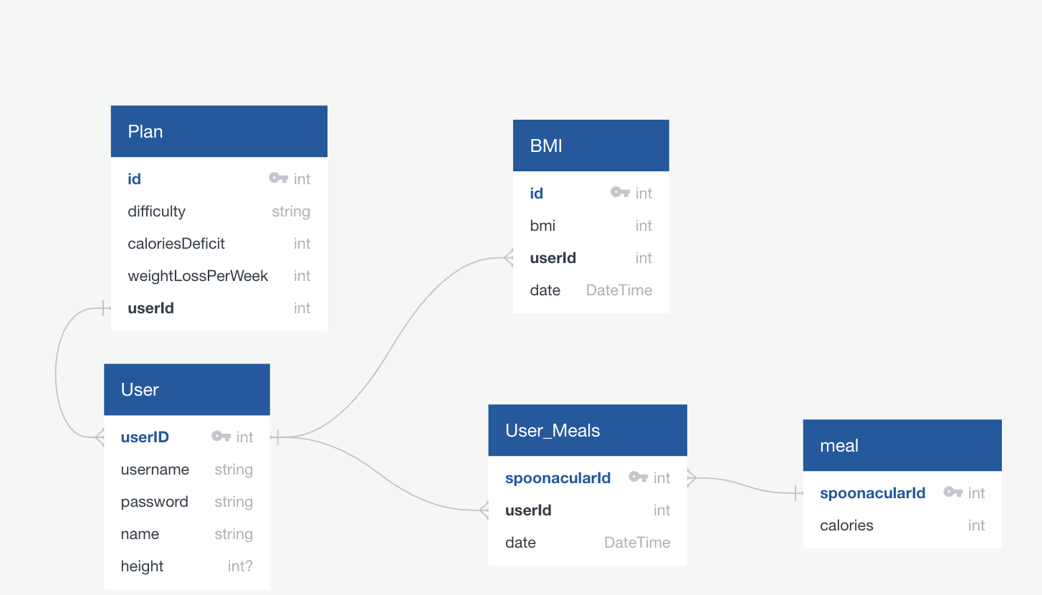

b. What kinds of issues might you run into with your API?

Daily free limit of requests, response error

c. Is there any sensitive information you need to secure?

User password, api key

d. What functionality will your app include?

Track bmi by date, track food intake by date, and goal reached.

e. What will the user flow look like?

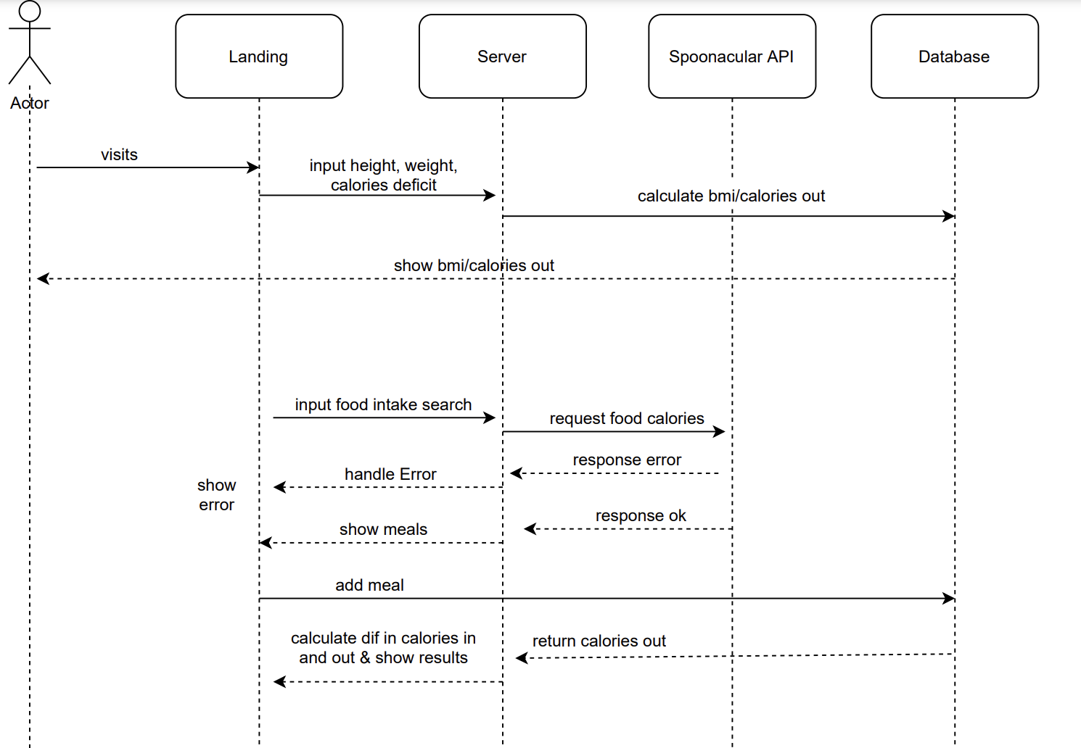

f. What features make your site more than CRUD? Do you have any stretch goals?

Stretch goals:

* Add exercises that increase calories burnt.
* Collect nutrients information, both macros and micronutrients
* Collect prices of food
* Add random quotes from Universal Inspirational Quotes API
* Add posts functionally for users, & comments on posts, & likes on both comments and posts.